Post meeting recommended changes. The client emphasized the direction of energy efficiency search information.

Sitewide: Change styles to match Greenworks logo styles

<https://master.d34euxgat8he4y.amplifyapp.com/>

Home page changes

* Remove apartment, condo buttons
* Add radio button
  + Address
  + Location
* Simple search options
  + Address text box
  + Area drop down
    - South Orlando
    - Attractions
    - Downtown
    - Winter Park
    - Maitland
    - Apopka
    - Etc
  + Search button

Search results changes

* Show map of property locations with color coded markers based on energy efficiency ranges
* Change the search results view from property images to a list view of key fields
* 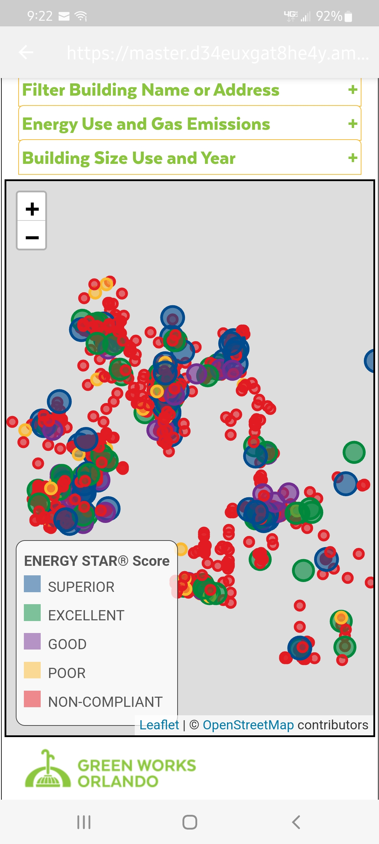See grid from this site

https://master.d34euxgat8he4y.amplifyapp.com/

Advanced Search

* 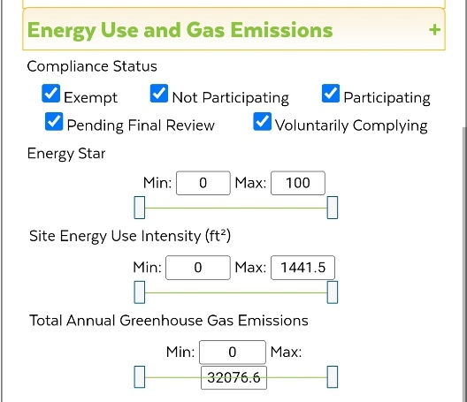Hide existing advanced search options for possible use later
* Add energy star ranges (check box list
* Add location drop down from home page
* Add address search box
* Add these fields (From image)
  + Property name
  + building size
  + Year built
  + Energy star ratings. Use a color-coded marker. Checkbox list.
  + Site Energy Use Intensity
  + Total Annual Greenhouse Gas Emissions
  + Site EIU
  + Source EIU
  + Greenhouse Gas Emissions
  + Use this equation (name?) EUI \* sqft \* rate of power